OFFICE OF THE HEAD OF CIVIL SERVICE
PUBLIC SECTOR REFORM FOR RESULTS PROJECTS
TRAINING OF STAFF OF MANAGEMENT SERVICES DEPARTMENT

- Introduction
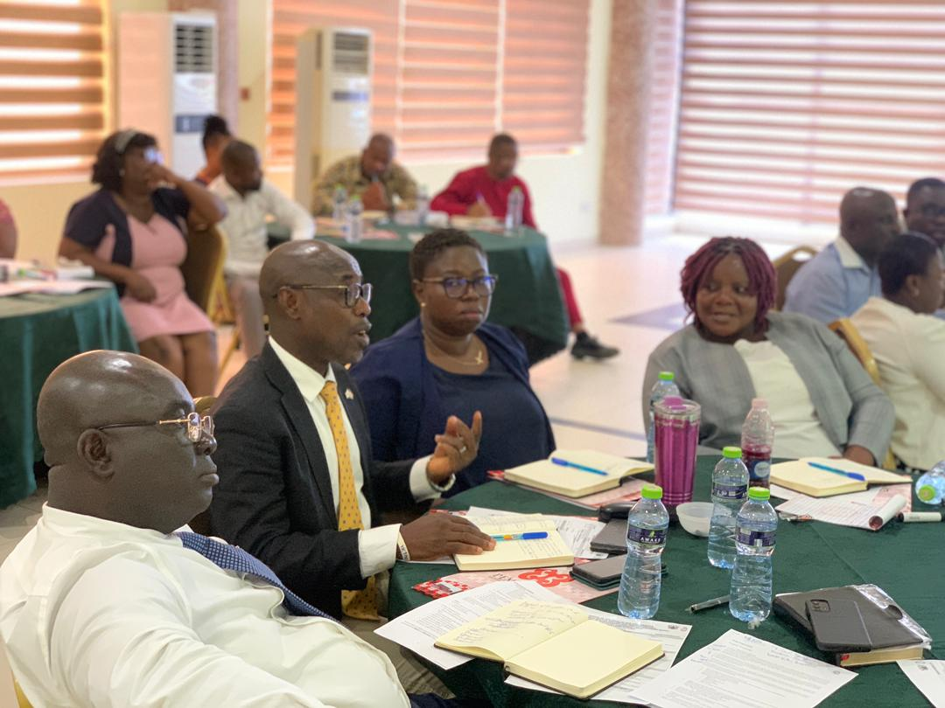
The Management Services Department (MSD) exists to lead the Civil/Public Service to implement policies and strategies on Institutional Development and Performance, build capacity in support of the attainment of their mandates. The Department conducts management and operational reviews or audits of Ministries Departments and Agencies /Public Boards and Corporations.
Participants having Discussions at the Training Session

As part of the implementation of the OHCS component of the Public Sector Reforms for Results Project, Management Analysts were trained in Business Process Re-engineering. The aim was to build the competence of Management Analysts to provide the necessary support to Ministries and Departments to undertake systems and procedures reviews to enhance their service delivery. It was also to enable the participants gain the knowledge and skills in process and systems management for business process transformation in the Ministries and Civil Service Departments.
Participants having Discussions at the Training Session
The training programme was held in two (2) batches at the Pempamsie Hotel, Cape Coast from the 4th to 16th December, 2022. It was sponsored by the World Bank as part of the Public Sector Reform for Results Project (PSRRP) and facilitated by Dexterity Consultancy Limited.

- Engagement of consultant
On 24th August, 2022, the Project Management Unit (PMU) of the PSRRP signed a contract with Dexterity Consultancy Limited to develop capacity of MSD staff in Systems and Procedures, and related reviews. The consultant was tasked among others to:
- Conduct a training needs assessment and develop a training schedule for the various categories of staff,
- Develop a Training and Operational manual for the conduct of Work-study, Work measurement, Automation of service/processes, E-Processes, Business Re-Engineering and other Services,
- Train staff of MSD in work study, work measurement, automation of service/processes, E-Processes, Business process reviews and re-engineering and other services, and
- Provide support to MSD / OHCS to pilot and document systems and procedures and related reviews in ten (10) selected MDAs with the aim of ensuring institutional alignment for improved service delivery.

- Implementation of the Training

Fifty-Eight (58) Officers, comprising Management Analysts and staff from Office of the Head of the Civil Service whose work schedule was directly related to Management Services Department participated in the training.
The training programme was preceded by a needs assessment exercise where capacity gaps were identified, and manual developed to facilitate training to address those gaps.
Head of Civil Serviced and Chief Director, OHCS
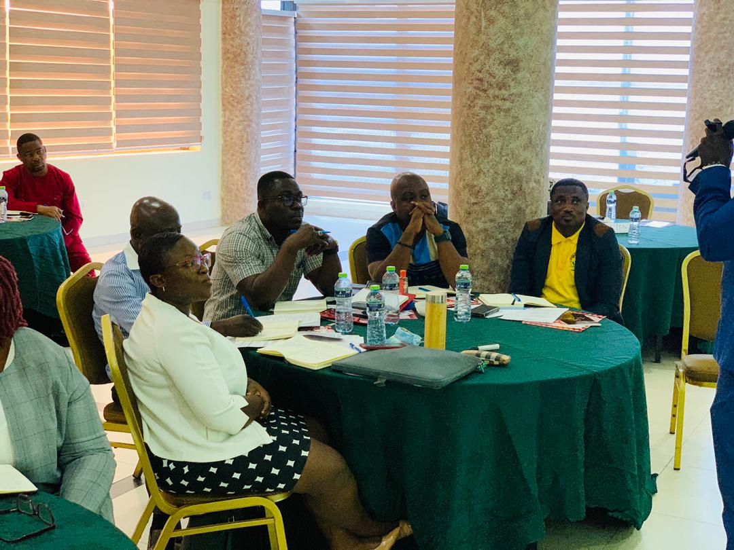
At the opening ceremony, the Head of Civil Service, Nana Agyekum Dwamena, admonished participants to consider the training programme as very important for the transformation of the work of Management Analysts. He was hopeful that the knowledge gained from the training, when fully operationalised, will make the Management Service Department the “go to” organisation for Management Consultancy in the Civil and Public Service.
Participants at the Training Session
The training contents focused on Business Process Review, Time and Motion Study, Business Process Re-engineering and Business Process Automation.

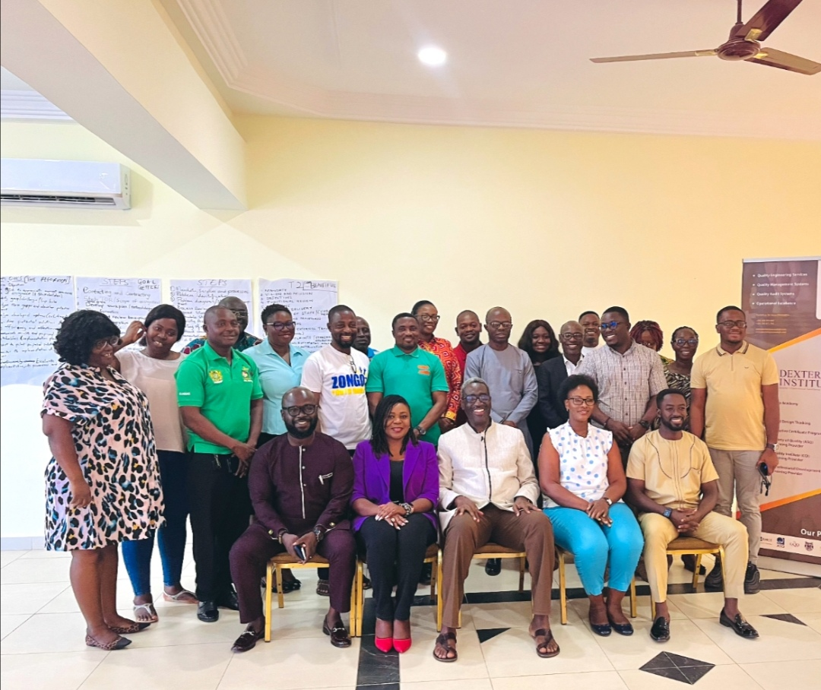
- Practical session
Participants with Officials from the Births and Deaths Registry
As part of the training, participants were tasked to analyse the work of the Births and Deaths Registry (BDR) using the principles of Business Process re-engineering. Officials from BDR were invited to participate and listen to the recommendations for improving work processes of the Department.
The immediate results were suggestions on how to eliminate waste, reduce time spent in the delivery of service and automation of processes to facilitate efficiency and effectiveness of the work process.
The Head of Civil Service tasked the officials from the BDR to liaise with Management Services Department to fully undertake the assignment.

- Conclusion
The training was successful as there was demonstration of learning in the presentations of the various groups during the exercise. The next phase is the pilot exercise in ten (10) institutions to improve service delivery.

